Western Trail Rides
Summer Horse Camp
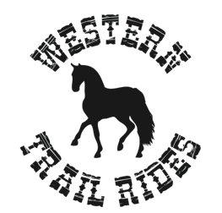

It’s time to round them up for some summer fun!
Join Melissa White of Western Trail rides for a week of horsing around at our Summer Horse Camp for children 6 years and older. Pick your week and reserve your spot!

Week 1: June 16-20 Week 6: July 28-Aug 1
Week 2: June 23-27 Week 7: August 4-8
Week 3: July 7-11 Week 8: August 11-15
Week 4: July 14-18
Week 5: July 21-25



Camp is Monday – Friday from 9am – 12pm the week will include horseback riding, grooming, crafts and horse related games and activities. Please complete and return the registration form below, and include your non-refundable deposit of $100.00. This amount will be applied to child’s camp tuition. Total cost for the week is $350.00. Please make check payable to “Western Trail Rides.” Call Melissa White with any questions at
805-640-8635. www.westerntrailrides.org
WTR Summer Camp Registration Form:

Camper’s Name: _________________________________________ Age: ______________
Parent / Guardian’s Name: ____________________________________________________
Day Phone: ____________________________ Evening Phone: _______________________
Week Preference First Choice #_________________ Second Choice #____________________
Mail to: Western Trail Rides
P.O. Box 1013
Ojai, Ca 93024

